Guardrails: Step-by-Step Implementation Guide
Time-box: 10 minutes. Hand out during Lab 4.

The one rule for this lab
Write every answer yourself, before you open Copilot. Guardrails exist to constrain the agent — if the agent drafts the rules meant to govern it, you haven’t built a guardrail, you’ve built a suggestion. The AI only gets a turn at the very end, and only to critique your plan, never to write it.
Checklist for this lab, in order:
- Step 1 — Turn on branch protection
- Step 2 — Prove it: a blocked push
- Step 3 — Write the rollback runbook
- Step 4 — Score the risk, decide go/no-go, then wire it into your pipeline
- Step 6 (optional) — Prove the gate with 3 test pull requests

Step 1 — Turn on branch protection
In your repo on GitHub:
- Go to Settings -> Branches.
- Under “Branch protection rules”, click Add classic branch protection rule
- Branch name pattern: main
- Tick Require a pull request before merging.
- Remove require approvals tickbox (later if required the pipeline will enforce a review)
- Tick Require status checks to pass before merging, then search for and select the build and test checks so they’re required.
- Tick Do not allow bypassing the above settings. This is the box people skip — without it, you (the admin) can still push straight to main, silently, and Step 4 below will fail to prove anything.
- Click Create (or Save changes).

Step 2 — Prove it
Try to push directly to main:
git checkout main
git pull
git commit --allow-empty -m "guardrail test: should be rejected"
git push origin main
Expected result: the push is rejected, with a message like:
GH006: Protected branch update failed
Changes must be made through a pull request.
If the push succeeds, the “Do not allow bypassing the above settings” box in Step 2 is not ticked — go back and fix it, then repeat this test. (If your repo is private on a free personal plan, branch protection and required reviewers are not enforced at all — make the repo public first; there’s nothing sensitive in it.)
Write the actual output you saw in your worksheet as your proof.
When this is done your main might be out of sync so run
git reset --hard origin/main

Step 3 — Write the rollback runbook
For every pull request change you will want to have a rollback runbook , generally the rollback will be a simple git revert but it may well be more complicated when dealing with database changes or infrastructure changes. Usually you would simply echo out the revert command in the logs for anyone supporting to read. An example is in the code below
Head_sha="${{ github.event.pull_request.head.sha }}"
pr_number="${{ github.event.pull_request.number }}"
echo "Rollback: git revert $head_sha"
echo "(If PR #$pr_number is squash-merged, that SHA won't exist on main — instead run:"
echo " gh pr view $pr_number --json mergeCommit -q .mergeCommit.oid"
echo " then git revert <that SHA>.)"

Step 4 — Score the risk and decide go/no-go
Based on the below you should score the change to decide if it can just be merged , if a senior developer needs to review or if it is too much of a risk to me made at one time

- Change size (1 for single file 5 for lots)
- Critical path impact (1 for comment or minimal change 5 for drastic structural change)
- Test confidence after the change (1 if it most likely won’t change 5 if you think it will break tests)
- Rollback readiness (is step 3 solid ? then 1 5 if risky)
Add them up (range 4-20):
Total | Decision
4-8 | Normal review path
9-14 | Senior reviewer required (needs an approving review from a code owner)
15-20 | No-go — reduce risk first

Step 3 and 4 in code — wire it into your own pipeline
You just scored risk by hand. Now make it real: add the same two jobs below to your own .github/workflows/ci.yml so every future pull request is scored and gated automatically, with no person typing in a number.
- Create a branch (for example add-risk-gate).
- Open .github/workflows/ci.yml and add the risk_assessment and deploy_preview_guarded jobs below, adjusting needs: if your existing job names differ from build/test.

risk_assessment:
if: github.event_name == 'pull_request'
needs: [build, test]
outputs:
risk_score: ${{ steps.score.outputs.risk_score }}
decision: ${{ steps.score.outputs.decision }}
steps:
- uses: actions/checkout@v5
- id: changed_paths
uses: dorny/paths-filter@v3
with:
filters: |
workflow:
- '.github/workflows/**'
app_logic:
- 'scripts/**'
- 'package*.json'
- id: score
run: |
score=4
if [[ "${{ steps.changed_paths.outputs.workflow }}" == "true" ]]; then
score=$((score + 7))
fi
if [[ "${{ steps.changed_paths.outputs.app_logic }}" == "true" ]]; then
score=$((score + 5))
fi
if [[ "${{ github.event.pull_request.changed_files }}" -gt 20 ]]; then
score=$((score + 4))
fi
if [[ "$score" -ge 15 ]]; then
decision="no-go"
elif [[ "$score" -ge 9 ]]; then
decision="senior-review"
else
decision="normal-review"
fi
echo "risk_score=$score" >> "$GITHUB_OUTPUT"
echo "decision=$decision" >> "$GITHUB_OUTPUT"
deploy_preview_guarded:
if: github.event_name == 'pull_request'
needs: [build, test, risk_assessment]
timeout-minutes: 5
permissions:
pull-requests: read
environment:
name: workshop-preview
steps:
- name: Block no-go risk levels
if: needs.risk_assessment.outputs.decision == 'no-go'
run: |
echo "Risk score ${{ needs.risk_assessment.outputs.risk_score }} is no-go."
echo "Apply mitigations, then rerun validation."
exit 1
- name: Require code owner (senior) approval for elevated risk
if: needs.risk_assessment.outputs.decision == 'senior-review'
env:
GH_TOKEN: ${{ secrets.GITHUB_TOKEN }}
run: |
decision=$(gh pr view "${{ github.event.pull_request.number }}" \
--repo "${{ github.repository }}" \
--json reviewDecision -q .reviewDecision)
echo "Review decision: $decision"
if [[ "$decision" != "APPROVED" ]]; then
echo "Missing required senior (code owner) approval"
exit 1
fi
- name: Approval and rollback notes
run: |
echo "Guardrail check passed after build+test."
echo "Risk score: ${{ needs.risk_assessment.outputs.risk_score }}"
echo "Decision: ${{ needs.risk_assessment.outputs.decision }}"
head_sha="${{ github.event.pull_request.head.sha }}"
pr_number="${{ github.event.pull_request.number }}"
echo "Rollback: git revert $head_sha"
echo "(If PR #$pr_number is squash-merged, that SHA won't exist on main — instead run:"
echo " gh pr view $pr_number --json mergeCommit -q .mergeCommit.oid"
echo " then git revert <that SHA>.)"

- Commit, push, and open a pull request — same discipline as Lab 3: read your own diff, self-review, then merge as admin.
- Expect this PR itself to score senior-review or higher, since it touches a workflow file — that’s your code working so switch to your reviewer user and review

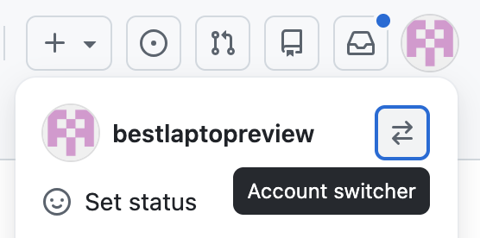
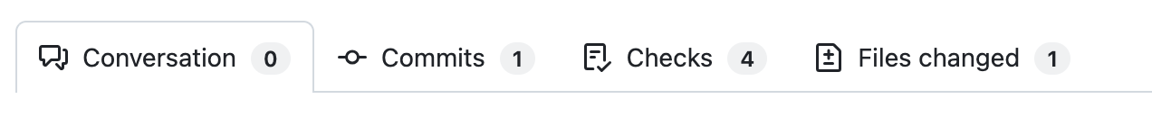
In the pr click Files changed

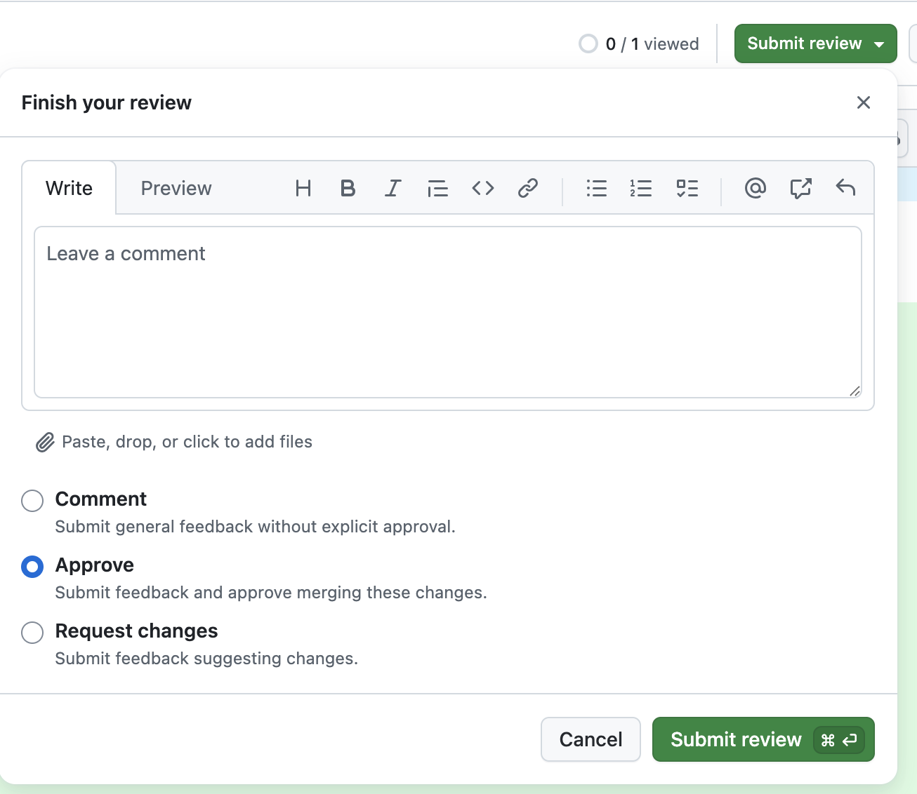

Hit submit review and approve

Finally switch back to your original user and click the merge button 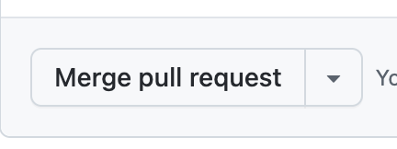
After the merge has happened there is one final step

As per Step one at the start of the document you need to add deploy_preview_guarded
To your Require status checks to pass before merging list

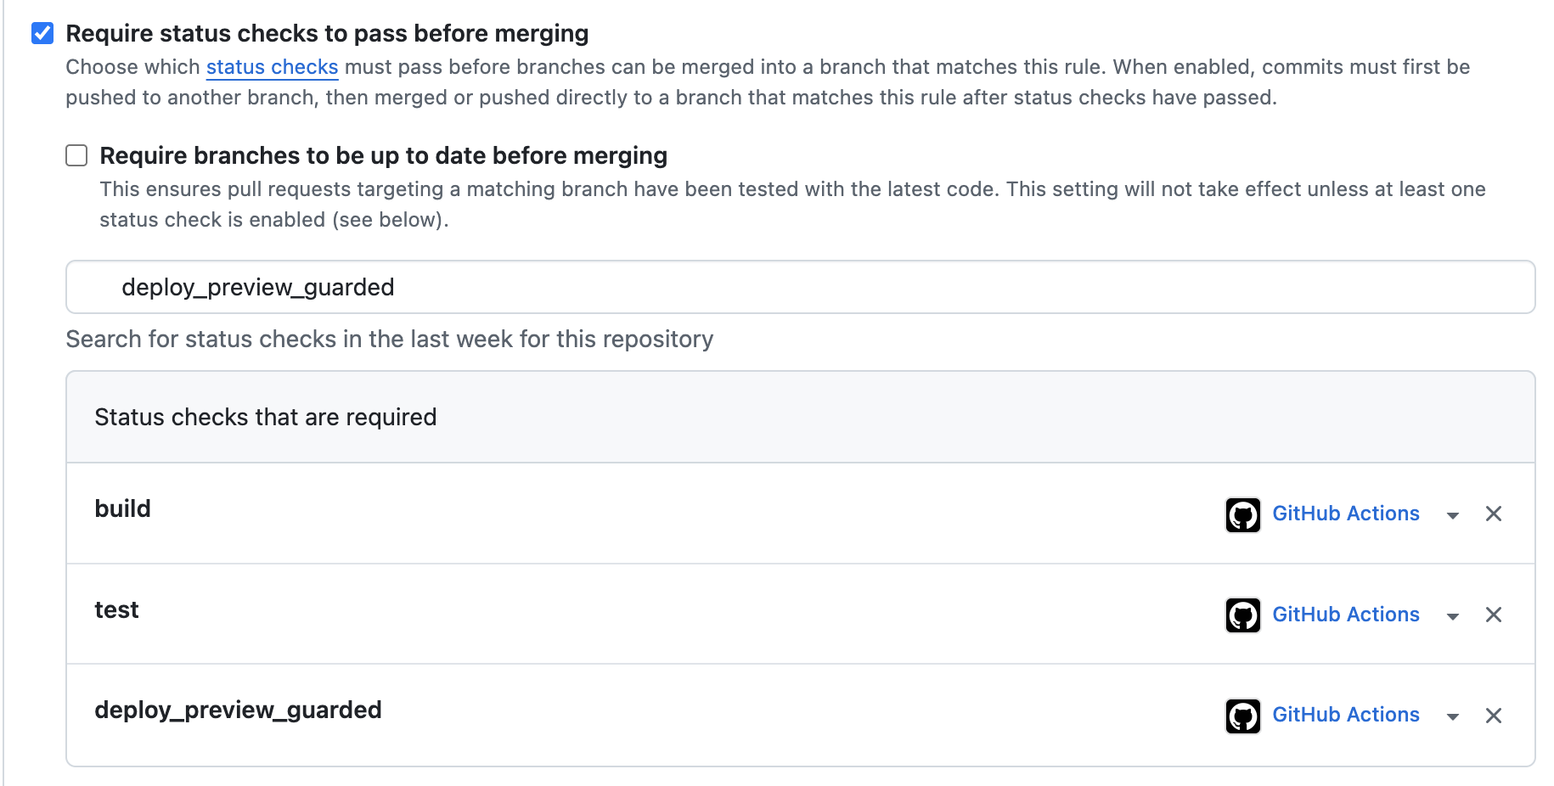

How the four manual dimensions map onto this code:
- Change size / critical path impact -> dorny/paths-filter checks which paths changed. Touching .github/workflows/** (the pipeline itself) adds 7; touching scripts/** or package*.json (app logic) adds 5. A baseline score of 4 stands in for “some risk always exists”, matching the worksheet’s 4-20 range. Touching both in the same PR already crosses into the no-go band on its own (4+7+5=16) — deliberately, since changing the pipeline and the app logic at once is exactly the combination this guardrail should stop.
- Rollback readiness / blast radius -> the changed_files count adds 4 more points once a PR touches more than 20 files, on the theory that large diffs are harder to roll back cleanly.
- Test confidence -> not scored directly here; risk_assessment only runs after needs: [build, test] succeed, so a failing pipeline never reaches a risk decision at all.
- The thresholds (>= 15 no-go, >= 9 senior-review, else normal-review) are the exact 4-8 / 9-14 / 15-20 bands from the table above, just written as a script instead of read off a chart.
The deploy_preview_guarded job then enforces the decision output. This is the part that actually implements Step 3’s environment gate and Step 5’s scoring as one guardrail, so read it end to end:
Four things worth pointing out:
- environment: name: workshop-preview is what pauses this job on the required reviewer you set up in Step 2 — the job cannot even start running its steps until someone clicks approve, regardless of what the risk score says.
- needs: [build, test, risk_assessment] means the environment approval gate, the quality gate, and the risk gate all have to clear before this job runs at all — none of them can be satisfied in isolation.
- Block no-go risk levels hard-fails the job with exit 1 on a no-go decision. There is no override; the only way past it is to reduce the score and get a fresh no-go -> senior-review or normal-review result.
- Require code owner (senior) approval is the automated version of the senior-review row in your table — it asks GitHub for the PR’s reviewDecision, which only reads APPROVED once the branch protection rule from Step 2 (“Require review from Code Owners”) has actually been satisfied by one of the senior developers listed in .github/CODEOWNERS. There’s no label to remember to add; the check reflects the real review state instead of a manually-applied tag that could be added by anyone.
The last step’s rollback notes are worked out from real PR context rather than typed as a canned sentence — github.event.pull_request.head.sha and the PR number are enough to print an exact, copy-pasteable git revert command, plus the squash-merge fallback (look up the real commit that landed on main with gh pr view --json mergeCommit). It still only prints the command; it does not execute it, because whether you actually want an automatic revert, a feature-flag flip, or a previous-artifact redeploy is repo-specific and worth a human’s eyes first.

Step 6 (optional) — Prove the gate across all three risk tiers
Now that the gate is live on your main, open Copilot agent mode and use Card 3 — Guardrail Demo in templates/ai_prompt_cards.md. It has the agent open three small test pull requests, each engineered to land in a different decision band, so you watch the gate allow, escalate, and block instead of taking it on faith:
- normal_review branch -> expect normal-review (score 4-8)
- senior_review branch -> expect senior-review, blocked until a code owner approves (score 9-14)
- no_go branch -> expect no-go, hard-blocked with no override (score 15-20)
For each one, open the PR’s Checks tab and confirm the risk_assessment score and the deploy_preview_guarded result actually match the table above. Do not merge the senior_review or no_go PRs — close them once you’ve confirmed the gate behaved correctly, then delete all three branches as cleanup.

Troubleshooting
- Push to main was not rejected in Step 3. Recheck “Do not allow bypassing the above settings” in Step 1 — without it, admins bypass the rule silently.
- Required reviewers option is missing under Environments. Your repo is private on a free plan; environments with required reviewers need a public repo (or a paid plan).
- senior-review decision blocks your PR. Get an approving review from one of the senior developers listed in .github/CODEOWNERS (set up in Step 2) — the check reads the PR’s reviewDecision, not a label, so nothing to add manually except the review itself.
- Score lands at 15-20 (no-go). Don’t force it through — shrink the change, add tests, or firm up the rollback plan, then rescore.

